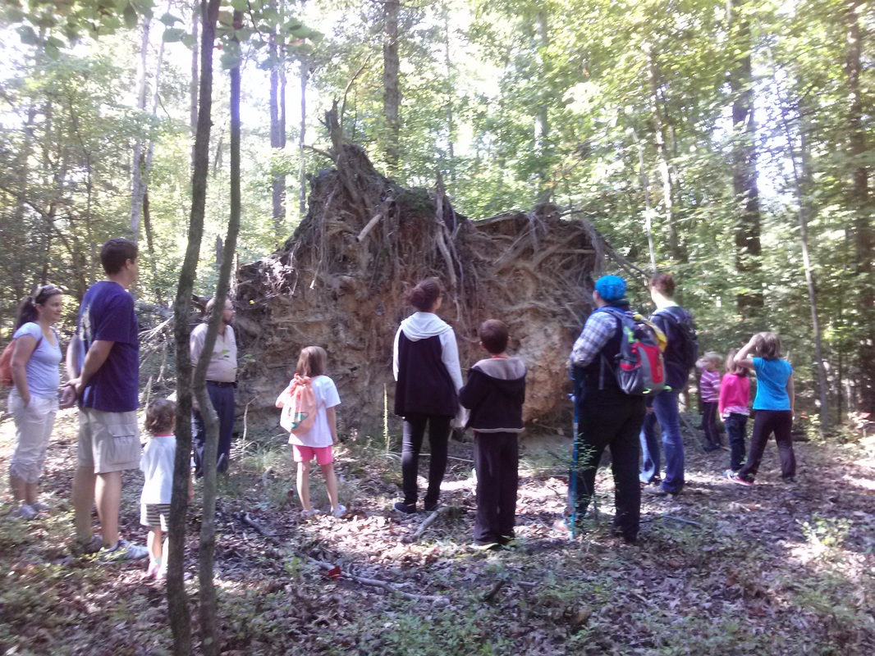  Our Mission  - To bring families back to the great outdoors through camping, hiking, skiing, canoeing, rafting, and other fun activities.  - To provide a safe and secure outlet for children of all ages to learn and explore at their own level and on their own terms.  - To develop social and group building skills through group games, sports, field trips, and community service activities.  - To encourage growth in all areas of personal development: social, physical, intellectual, creative, and emotional. We aim to spark intellectual curiosity in all areas, especially the areas related to the natural sciences and nature."  - To have the ability to take what we learn in scouts and apply it to our daily lives. |  |  | Who We Are  Navigators USA is a gender-inclusive, diversity-focused scouting program for children ages 4 to 17, as well as for adult volunteers. Our chapter, Chapter 58, is participant-led, meaning scouts have a direct influence over choosing and leading the activities in which they’d like to participate. Through our program scouts develop life, leadership and team building skills, make new friends, connect with nature, give back to their community, care for their country and ultimately their planet.  Contact Us  Email: Chapter58@navigatorsusa.org  Web: http://chapter58.weebly.com  Facebook: Navigators USA, Chapter 58  CHAPTER 58  Unitarian Universalist Fellowship of the Peninsula  415 Youngs Mill Road  Newport News, VA 23602 |  |  | CHAPTER 58  Scouting for Everyone!  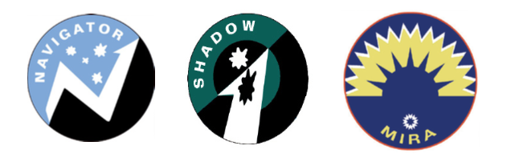

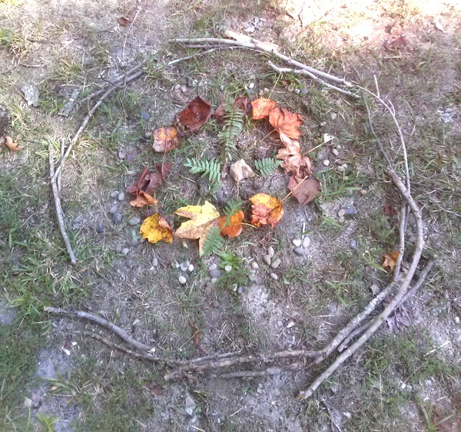  When do we meet?  - Regular meetings occur monthly, September through June, on the third Wednesday of the Month.  - Stargazers & Juniors meet 6 to 7 p.m.  - Seniors meet 7 to 8 p.m.  - Regular outings are planned on the first Saturday of each month; September through June.  Where are meetings held?  - Regular meetings are held in the UUFP Religious Education room (main building)  - Outings change monthly so stay tuned to our Facebook, webpage, or google calendar for up-to-date information. |  |  | Our Promise  As a Navigator I promise to do my best to create a world free of prejudice and ignorance.  To treat people of every race, creed, lifestyle and ability with dignity and respect.  To strengthen my body and improve my mind to reach my full potential.  To protect our planet and preserve our freedom.  “I love everything about being a Navigator! My favorite part is having NEW experiences!”  -Karina  Senior Navigator  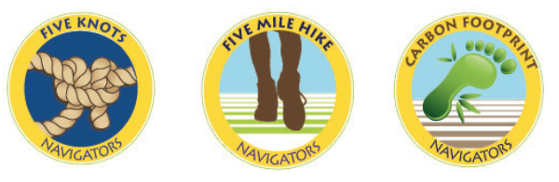  . |  |  | Our Groups  Stargazers  Ages 4-6  Juniors  Ages 7-10  Seniors  Ages 11-17  How do I register/volunteer?  - Stop by one of our meetings or  - Visit our website and download the Registration Booklet and bring it to our next meeting. http://chapter58.weebly.com  - Volunteer opportunities are available. Contact us at Chapter58@navigatorsusa.org to discuss where you’d like to lend a hand.

